* Over half of job seekers spend more time searching for jobs than dating—job searching can be overwhelming
* To focus your efforts effectively, use your transferable skills and career identity statement as filters to find platforms aligned with your goals
* General job boards like CareerBuilder, Indeed, and Glassdoor are common starting points
* Google Career Certificate grads should explore job postings from employer consortium members seeking their skills
* Niche job boards target specific industries, e.g.:
  + Behance for creatives
  + USAJOBS for government roles
* Professional associations (e.g., National Health Career Association) are valuable resources and often post jobs or host networking events
* Company websites can act as niche job boards if you’re targeting specific employers
* Maintain a list of job platforms you find useful and check them regularly
* Use a mix of general boards, specialized platforms, and association sites for thorough coverage
* Gemini Deep Research can help uncover more targeted job boards based on your industry, role, experience, and location—craft specific prompts to get tailored results
* When identifying job leads, research hiring companies by:
  + Visiting their official websites and social media to gather insights and interview talking points
  + Reading employee reviews on Glassdoor to understand company culture and environment
* Focusing your search on platforms and companies aligned with your skills helps avoid overwhelm and makes your job search more efficient and effective

**Organizing Your Job Search:**

* Job application phase can be lengthy and involve many resumes submitted
* Staying organized is key—use tools like Gemini and Google Sheets to track applications
* Essential tracker fields:
  + Job title, company, job posting link, date applied
  + Resume and cover letter versions used
  + Company details: name, website, industry
  + Application progress: dates of calls, interviews, offers, rejections
* Including a brief job description summary helps differentiate similar roles—use Gemini to summarize job postings in 2-3 sentences
* Keep both the full job posting link and summarized description in the tracker
* Company research is critical for informed applications and interviews:
  + Explore company website, LinkedIn, news, social media to understand culture and priorities
  + Use Gemini Deep Research for detailed company analysis and insights on business drivers
  + Ask Gemini to prepare research reports and audio summaries, especially before interviews
* Gemini Deep Research may be less effective for very small or local businesses with limited online info
* Summarize company research with Gemini for easy entry into your tracker
* Use a Job Search Tracker template to start, customize it like a resume to fit your needs
* Continuously update your tracker as a living document during your job search
* Add your tracker to a job search portfolio to keep everything organized and accessible

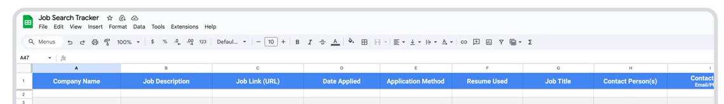

**Building Resilience as a Job Seeker:**

* A.J. works with retired NFL players helping them transition to new careers
* Focus areas include career exploration, skill identification, and resume design
* Job searching today can be long and challenging due to varying company policies, timelines, and competition
* Resilience is a crucial, often underrated skill for job seekers
* Advice to maintain morale during job search:
  + Be programmatic and disciplined (set daily goals for applications, outreach, or skill-building)
  + Celebrate small wins like interview invitations to build momentum
  + Understand that success comes from planting seeds weeks or months ahead
* Handling rejection:
  + Don’t take it personally; many applicants compete for one role
  + Reframe rejections as learning opportunities to improve skills and strategies
  + Accept that some factors are out of your control and focus on perseverance
  + Keep a mindset of getting back up and continuing despite setbacks